Sistem Pendukung Keputusan Dalam Menentukan Hasil Tes Calon Programer Baru Menggunakan Metode FAHP

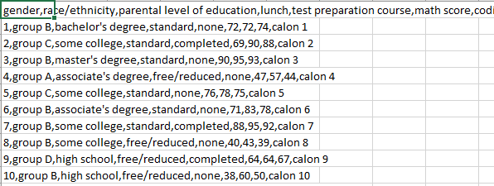

|  |  |  |  |
| --- | --- | --- | --- |
| Calon ke | Coding | Math | Theory |
| 1 | 72 | 72 | 74 |
| 2 | 69 | 90 | 88 |
| 3 | 90 | 95 | 88 |
| 4 | 47 | 57 | 44 |
| 5 | 76 | 78 | 75 |
| 6 | 71 | 83 | 78 |
| 7 | 88 | 95 | 92 |

Ketentuan:

Coding 4x lebih besar daripada theory

Coding 3x lebih besar daripada math

Math 2x lebih besar daripada theory

Relasi Antar matrik

|  |  |  |  |
| --- | --- | --- | --- |
| Kriteria | Coding | Math | Theory |
| Coding | 1 | 3 | 4 |
| Math | 0 | 1 | 2 |
| Theory | 0 | 0 | 1 |

Range akhir:

|  |  |
| --- | --- |
| **Range** | **Ket** |
| >7.9 | Lolos |
| <7.9 | Tidak Lolos |